Family Name: |  |  |  |  | Tel No.
Address: |  |  |  |  | Email:
Members  in  Household: | Relationship e.g. Father, Child, Grandparent | Date of Birth | Marital Status  M – Married  W - Widowed  S – Single  A – Separated  D – Divorced  P – Partnership | Occupation  Or  School | Would you like to be involved in a Parish Ministry e.g. Music, Reader, St. V. De Paul, Draw etc. | I would like to receive weekly envelopes
Name
Name

Name

Name

Name

Name

Name

Name

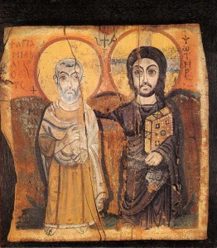
PARISH REGISTRATION PARISH OF ANTRIM, 3 ORIEL ROAD, ANTRIM, BT41 4HP
Tel: 94428016, email: stcomgalldc@tiscali.co.uk

